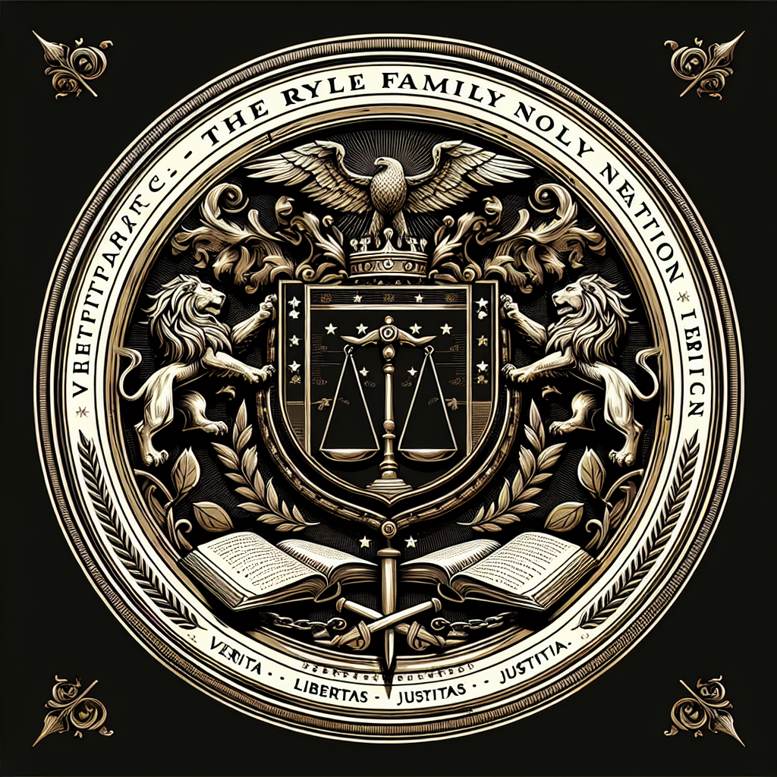
11/9/2025
,
.

Plaintiffs AZTEC CONSTRUCTORS, INC. and AZTEC CONSULTANTS (collectively “Plaintiffs” and/or “AZTEC”), hereby complains, avers, and alleges against Defendants TRAVIS RYLE, THE TRAVIS RYLE PRIVATE BANK ESTATE & TRUST, and DOES 1-50, inclusive, as follows:

THE PARTIES
- At all relevant times, Plaintiff AZTEC CONSTRUCTORS, INC., is and at all times relevant hereto was, a corporation organized and existing under the laws of California, with its principal place of business in Contra Costa County, California.
- At all relevant times, Plaintiff AZTEC CONSULTANTS, is and at all times relevant hereto was, a corporation organized and existing under the laws of California, with its principal place of business in Contra Costa County, California.
- Plaintiffs are informed and believe, and based thereon allege, that Defendant TRAVIS STEVEN RYLE (“Travis”), is and was an individual residing in the State of Arizona. Plaintiffs are currently unaware of Defendant’s full legal name and will amend this Complaint when it becomes known.
- Plaintiffs are informed and believe, and based thereon allege, that Defendant THE TRAVIS RYLE BANK-ESTATE AND TRUST (“Ryle Bank”), is an entity of unknown form and origin that purports to operate as a trust or fiduciary institution located at 5570 W. Tonto Pl, Golden Valley, Arizona, 86413.
- Plaintiffs are ignorant of the true names and capacities of defendants sued herein as DOES 1 through 50, inclusive, and therefore sues these defendants by such fictitious names. Plaintiffs will amend this complaint to allege their true names and capacities when ascertained. Plaintiffs are informed and believe and thereon allege that each of such fictitiously named defendants is responsible in some manner for the occurrences herein alleged, and that Plaintiffs’ damages as herein alleged were proximately caused by such defendants.
- At all times herein mentioned Defendants and DOES 1 through 50 were the agents, servants, and employees of their co-defendants, and in doing the things hereinafter alleged were acting in the scope of their authority as such agents, servants, and employees, and with the permission and consent of their co-defendants.
- Where appearing in this complaint, each and every reference to “Defendants” or to any of them, is intended to be and shall be a reference to all defendants hereto, and to each of them, named and unnamed, including all fictitiously named defendants, unless said reference is otherwise specifically qualified including, but not limited to, Travis, Ryle Bank, and DOES 1 to 50.

JURISDICTION AND VENUE
- Jurisdiction is proper in this Court pursuant to California Constitution Article VI, Section 10 and CA Code of Civil Procedure § 410.10.
- Jurisdiction is proper because Defendants purposefully directed fraudulent activities toward Plaintiffs in California, including the filing of knowingly false and unauthorized UCC-1 and UCC-3 Financing Statements and related lien documents with the California Secretary of State. Defendants have engaged in wrongful acts and caused injury in the State of California, and this action arises out of business conducted in California by the Defendants.
- Venue is proper in Contra Costa County under Code of Civil Procedure § 395(a) because the wrongful acts and injury occurred within this county and venue and judicial district at or near Contra Costa County.

FACTUAL ALLEGATIONS
- In or around 2022, Defendants knowingly filed a 1099-A Acquisition or Abandonment of Secured Property Form with the Puerto Rico Department of Treasury and/or Internal Revenue Service (IRS). The filing includes Lender’s information: “TRAVIS STEVEN-RYLE SSN MORTMAIN VESSEL” 10 Paseo Covadonga, Sec. of Treasury, San Juna Puerto Rico 00901, PUERTO RICO – Phone: 7872007700. The filing also includes Borrower’s information, which appears to be an affiliated entity of Travis Ryle: “The Travis Ryle Bank-Estate and Trust CFO, 5570 w Tonto pl, Golden Valley AZ 86413 US, Lender’s Tin: 602-05-7209 and Borrower’s Tin: 92-6319308.” The filing purports the date of lender’s acquisition or knowledge of abandonment was 1/20/2002 with a balance of principal outstanding of $1,000,000.00, and a description of property noted as “SS Guarantee Assurance 104 0190 003558.” A true and correct copy of the 1099-A Form has been attached herein as “Exhibit A.”
- On or around June 16, 2025, Defendants knowingly filed a false UCC-1 Financing Statement with the California Secretary of State, File No. U250155131317, falsely asserting a security interest in “All now-owned or hereafter acquired personal property of Debtor, including but not limited to, equipment, inventory, accounts, contract rights, general intangibles, receivables, chattel paper, and business goodwill, together with all proceeds thereof.” A true and correct copy of the UCC-1 Financing Statement has been attached herein as “Exhibit B.”
- On or around June 16, 2025, Defendants knowingly filed a false UCC-3 Financing Statement Amendment with the California Secretary of State, File No. U250155301621, falsely asserting a security interest in “all Assets are assigned under the full control of The Travis Ryle Private Bank Estate & Trust. Termination of prior Claims and replacing with new Amendment adjusting owner ship structure. Revoke authorized Agent Frank E. Duarte.” A true and correct copy of the UCC-3 Financing Statement Amendment has been attached herein as “Exhibit C.”
- On or around June 20, 2025, Defendants knowingly filed a false UCC-3 Financing Statement Amendment with the California Secretary of State, File No. U250156939736, falsely asserting a security interest in “This amendment restates and expands the collateral description to include: All assets of the Debtor, including but not limited accounts receivable to include: All assets of the Debtor including but not limited to accounts receivable, general intangibles, inventory, equipment, chattel paper, deposit accounts, investment property, and proceeds thereof, whether now existing or hereafter arising. This includes, without limitation, the assets of any subsidiary, affiliate, parent entity, joint venture, agent, nominee, alter ego, or DBA operating under or in connection With Aztec Constructors Inc. irrespective of jurisdiction, naming connection, or operational framework.” A true and correct copy of the UCC-3 Financing Statement Amendment has been attached herein as “Exhibit D.”
- On or around June 21, 2025, Defendants mailed fraudulent correspondence to the Contra Costa County claiming ownership and interest in the assets of AZTEC CONSTRUCTORS, INC. over all current and future obligations of public funds due and owed to Plaintiff, while referencing the aforementioned fraudulent UCC-1 and UCC-3 Financing Statements with the California Secretary of State. A true and correct copy of the correspondence to Contra Costa County has been attached herein as “Exhibit E.”
16. On or around July 1, 2025 to July 3, 2025, Defendants sent text messages directly to Plaintiffs that include nonsensical and incomprehensible discussions related to Plaintiffs’ business in the State of California. A true and correct copy of the messages have been attached herein as “Exhibit F.”
- On or around July 16, 2025, Plaintiffs served Defendants with a Notice to Cease and Desist communications with the Contra Costa County Public Works Department regarding any claims to public funds due and owed to Plaintiff AZTEC CONSTRUCTORS, INC. A true and correct copy of the Notice to Cease and Desist has been attached herein as “Exhibit G.”
- On or around July 16, 2025, Defendants served a response to Plaintiffs’ Notice to Cease and Desist while referencing documents that attempt to substantiate the legality of Defendants’ businesses and affiliated entities and entitlement to enforce the fraudulent 1099-A filing with the Puerto Rico Department of Treasury and/or IRS, and UCC-1 and UCC-3 Financing Statements with the California Secretary of State. A true and correct copy of Defendants’ response and referenced documents have been attached herein as “Exhibit H.”
- Based on information and belief, on or around July 2025, Plaintiffs are aware and informed that Defendants served a request for documents to Solano County, similar to the request sent to Contra Costa County on or around June 21, 2025, claiming ownership and interest in the assets of AZTEC CONSTRUCTORS, INC. over all current and future obligations of public funds due and owed to Plaintiff, while referencing the aforementioned fraudulent UCC-1 and UCC-3 Financing Statements with the California Secretary of State.
- Plaintiffs have never entered into any security agreement, debt obligation, note, or any financial transaction with Defendants. Defendants have failed to produce to Plaintiffs or Plaintiffs’ counsel any valid legal documents constituting a security agreement, debt obligation, note, or financial transactions demonstrating the legality and propriety of the 1099-A filing with the IRS, or UCC-1 and UCC-3 Financing Statements with the California Secretary of State.
- Defendants’ actions have disrupted and endangered Plaintiffs’ contractual and economic relationships with the Contra Costa County Building Department and other public entities.
- Plaintiffs have suffered reputational harm, legal expenses, risk of future financing for business operations, and risk of loss of public contract payments as a result of Defendants’ fraudulent acts and harassment.

(FOR FRAUD)
(AGAINST ALL DEFENDANTS AND DOES 1-50)
- Plaintiffs refer to and incorporate by this reference all above allegations as though said allegations were fully set forth at length herein.
- Defendants knowingly made false representations concerning their authority and interest in Plaintiffs’ assets and contracts, including but not limited to the filing of a fraudulent Form 1099-A with the purported Puerto Rico Department of Treasury, UCC-1 and UCC-3 Financing Statements with the California Secretary of State in support of these misrepresentations.
- These misrepresentations included false claims of a secured interest in Plaintiffs’ present and future receivables and the purported assignment or control of funds owed by third parties, including public agencies, to Plaintiff.
- Defendants made these representations with knowledge of their falsity and with intent to deceive government agencies, financial institutions, and other third parties into recognizing Defendant’s baseless claims.
- Plaintiffs did not and could not have consented to these false claims, and has never executed any security agreement, debt obligation, promissory note, contract, or financial transactions demonstrating the legality and propriety of the 1099-A filing with the IRS, or UCC-1 and UCC-3 Financing Statements with the California Secretary of State.
- Defendants’ fraudulent conduct caused Plaintiffs to suffer actual damages, including reputational harm, disruption of business operations, lost income, and expenses related to clearing title and defending against the false lien.
- Defendants pursued the aforesaid course of wrongful and despicable conduct intentionally, maliciously and oppressively and constitutes clear and convincing evidence of despicable, outrageous, oppressive and malicious conduct, pursuant to Section 3294 of the California Code of Civil Procedure, entitling Plaintiffs to punitive and exemplary damages in an amount sufficient to punish and deter them from similar future conduct.

(SLANDER OF TITLE)
(AGAINST ALL DEFENDANTS AND DOES 1-50)
- Plaintiffs refer to and incorporate by this reference all above allegations as though said allegations were fully set forth at length herein.
- On or about June 16, 2025 to June 20, 2025, Defendant Kyle, without privilege or legal justification, knowingly and maliciously filed Form 1099A false UCC-1 and UCC-3 Financing Statements with the California Secretary of State, falsely asserting a security interest and lien against Plaintiffs’ assets, including present and future receivables.
- The false UCC-1 and UCC-3 Financing Statements were filed with the California Secretary of State, publicly recorded, and has had the effect of clouding Plaintiffs’ title to its receivables and contractual rights, thereby casting doubt on Plaintiffs’ ability to collect payments and perform under public and private contracts.
- Defendants’ statements were false and made with actual malice and knowledge of their falsity, or with reckless disregard for the truth.
- Defendants knew or should have recognized that public and private entities would reasonably and justifiably rely on the fraudulent filings of Form 1099-A with the Puerto Rico Department of Treasury and/or the IRS, and UCC-1 and UCC-3 Financing Statements with the California Secretary of State.
- As a direct and proximate result of Defendants’ slanderous statements, Plaintiffs have suffered pecuniary loss, including but not limited to loss of business opportunity, impairment of business reputation, and legal fees incurred to clear the false filings.
- Plaintiffs are entitled to actual damages in an amount to be proven at trial, as well as punitive damages due to the malicious and oppressive nature of Defendants’ conduct.

(FOR INTENTIONAL INTERFERENCE WITH CONTRACTUAL RELATIONS)
(AGAINST ALL DEFENDANTS AND DOES 1-50)
- Plaintiffs refer to and incorporate by this reference all above allegations as though said allegations were fully set forth at length herein.
- At all relevant times, Plaintiffs maintained valid and enforceable contractual relationships with third parties, including, but not limited to, the Contra Costa County Building Department and other public or private entities obligated to make payments for services rendered by Plaintiffs.
- Defendants knew of the existence of these contractual relationships. Despite this knowledge, Defendants intentionally engaged in wrongful conduct designed to disrupt and interfere with said contracts, including the filing of a fraudulent UCC-1 Financing Statement with the California Secretary of State and sending correspondence falsely claiming a right to Plaintiffs’ assets and receivables.
- Defendants had no legal or factual basis to assert any claim over Plaintiffs’ assets, contracts, or receivables and acted with the intent to prevent performance or induce breach of Plaintiffs’ existing contractual obligations with third parties.
- As a direct and proximate result of Defendants’ intentional interference, Plaintiffs have suffered damages, including, but not limited to, delayed or lost payments, reputational harm, and the incurrence of legal fees to challenge the false filings and protect its business interests.
- Plaintiffs are entitled to compensatory damages in an amount to be proven at trial and, because Defendants acted with malice, oppression, and fraud, Plaintiffs also seek punitive damages pursuant to Civil Code § 3294.

(FOR INTENTIONAL INTERFERENCE WITH PROSPECTIVE ECONOMIC ADVANTAGE)
(AGAINST ALL DEFENDANTS AND DOES 1-50)
- Plaintiffs refer to and incorporate by this reference all above allegations as though said allegations were fully set forth at length herein.
- At all relevant times, Plaintiffs had an economic relationship with third parties, including, but not limited to, Contra Costa County and Solano County, and other public or private entities, which were likely to result in future economic benefits or advantages to Plaintiffs.
- Defendants, and each of them, knew of these relationships and prospective opportunities.
- Defendants wrongfully and intentionally engaged in conduct designed to interfere with and disrupt these prospective relationships. Such conduct included, but was not limited to, the filing of fraudulent Form 1099-A, UCC-1 and UCC-3 Financing Statements and sending false correspondence to third parties asserting baseless claims to Plaintiffs’ receivables and business assets.
- Defendants lacked any legal or factual justification for their interference and acted with malice and in conscious disregard of Plaintiffs’ rights.
- As a direct and proximate result of Defendants’ wrongful acts, Plaintiffs’ economic relationships were disrupted, causing actual harm, including the loss of anticipated business, contractual delays, reputational damage, and legal expenses.
- Plaintiffs are entitled to compensatory damages in an amount to be determined at trial, as well as punitive damages pursuant to Civil Code § 3294 due to the intentional, fraudulent, and oppressive nature of Defendants’ conduct.

(FOR ABUSE OF PROCESS)
(AGAINST ALL DEFENDANTS AND DOES 1-50)
- Plaintiffs refer to and incorporate by this reference all above allegations as though said allegations were fully set forth at length herein.
- Defendants willfully and improperly used legal process, including, but not limited to, the fraudulent filing of Form 1099-A, UCC-1 and UCC-3 Financing Statements, assignments, and restated collateral statements with the California Secretary of State, to accomplish purposes for which the process was not designed.
- Defendants’ use of the legal process was not to lawfully establish any legitimate security interest, but instead to coerce, harass, and interfere with Plaintiffs’ legal and financial standing, fraudulently obtain payments due and owed to Plaintiffs, and to extract undue leverage over Plaintiffs’ ongoing business operations.
- Defendants’ actions in filing these fraudulent and baseless lien documents were done with ulterior motives and in a manner not proper in the regular conduct of legal proceedings or business filings.
- As a direct and proximate result of Defendants’ abuse of process, Plaintiffs have sustained damages, including, but not limited to, loss of revenue, damage to reputation, legal expenses, and disruption of contractual relations.
- Plaintiffs are entitled to compensatory damages and seeks punitive damages under Civil Code § 3294 due to the malicious and oppressive conduct of Defendants.

(FOR UNFAIR BUSINESS PRACTICES BUS. & PROF. CODE § 17200)
(AGAINST ALL DEFENDANTS AND DOES 1-50)
- Plaintiffs refer to and incorporate by this reference all above allegations as though said allegations were fully set forth at length herein.
- Defendants’ conduct, as described above, constitutes unlawful, unfair, and fraudulent business practices within the meaning of California Business and Professions Code section 17200 et seq. The acts and practices described herein are unlawful because they violate multiple statutory and common law prohibitions, including, but not limited to, fraud, abuse of process, and intentional interference with contractual relations.
- The conduct is also unfair in that it offends established public policy and is immoral, unethical, oppressive, and unscrupulous, and has caused substantial injury to Plaintiffs that is not outweighed by any countervailing benefits to consumers or competition. Defendants’ conduct is also fraudulent in that it was likely to deceive and did deceive members of the public, including third-party agencies and potential clients.
- As a direct and proximate result of Defendants’ unlawful, unfair, and fraudulent business practices, Plaintiffs have suffered economic injury, including, but not limited to, loss of revenue, reputational harm, and legal costs.
- Pursuant to Business and Professions Code section 17203, Plaintiffs seek an order of restitution and injunctive relief prohibiting Defendants from engaging in the unlawful conduct described herein, and requiring them to remove all fraudulent filings and cease further interference with Plaintiffs’ business activities.

(FOR NEGLIGENT MISREPRESENTATION)
(AGAINST ALL DEFENDANTS AND DOES 1-50)
- Plaintiffs refer to and incorporate by this reference all above allegations as though said allegations were fully set forth at length herein.
- At all relevant times, Defendants, and each of them, represented to government agencies, third parties, and the public, including the California Secretary of State, Contra Costa County Building Department, and Solano County that they possessed a valid and enforceable security interest in Plaintiffs’ assets, including, but not limited to, present and future receivables and contractual payments.
- These representations were made in documents including Form 1099-A filed with the Puerto Rico Department of Treasury and/or IRS, UCC-1 and UCC-3 Financing Statements with the California Secretary of State, in mailed correspondence, and in communications to third parties.
- Defendants made these representations without any reasonable grounds for believing them to be true and without conducting any reasonable investigation into the validity of their purported interest in Plaintiffs’ property or contracts.
- Defendants made these representations with the intent and expectation that third parties, including public agencies, private parties, and financial institutions, would reasonably rely upon them and act accordingly, to Plaintiffs’ detriment.
- Plaintiffs are informed and believe, and thereon allege, that third parties, including the Contra Costa County Building Department, Solano County, and others, did in fact rely on these false and negligent misrepresentations, which caused disruption of Plaintiffs’ payments and business operations.
- As a direct and proximate result of Defendants’ negligent misrepresentations, Plaintiffs suffered damages, including, but not limited to, reputational harm, interference with contractual and economic relationships, legal expenses, interest, and lost income.
- Plaintiffs are entitled to compensatory damages in an amount to be proven at trial.

(FOR DECLARATORY RELIEF)
(AGAINST ALL DEFENDANTS AND DOES 1-50)
- Plaintiffs refer to and incorporate by this reference all above allegations as though said allegations were fully set forth at length herein.
- An actual controversy has arisen and now exists between Plaintiffs and Defendants concerning the validity of the UCC-1 Financing Statement filed by Defendants Travis Ryle and/or THE TRAVIS RYLE BANK ESTATE AND TRUST, and any purported claims to Plaintiffs’ receivables, contracts, or assets.
- Plaintiffs contend, and are informed and believe, and Defendants dispute, that Defendants have no legal or equitable interest in Plaintiffs’ property or contractual rights and that any claim of security interest is wholly baseless, unauthorized, and fraudulent.
- Plaintiffs seek a judicial declaration pursuant to Code of Civil Procedure § 1060 that:
  - The Form 1099-A with the Puerto Rico Department of Treasury and/or IRS are void and of no legal effect.
  - The UCC-1 and UCC-3 Financing Statements filed with the California Secretary of State by Defendants are void and of no legal effect;
  - Defendants hold no valid or enforceable security interest, lien, or other right in Plaintiffs’ assets, receivables, or contractual payments.
  - Any further attempt by Defendants to assert such interests would be unlawful and subject to injunctive relief and sanctions.
72. A declaratory judgment is necessary and appropriate at this time so that Plaintiffs may ascertain their rights and obligations and prevent further injury to their business and reputation. Without such relief, Plaintiffs will continue to suffer uncertainty and irreparable harm.

(FOR INJUNCTIVE RELIEF)
(AGAINST ALL DEFENDANTS AND DOES 1-50)
- Plaintiffs refer to and incorporate by this reference all above allegations as though said allegations were fully set forth at length herein.
- Defendants have engaged in a continuing course of unlawful conduct by filing false and fraudulent lien documents, including Form 1099-A filed with the Puerto Rico Department of Treasury and/or IRS, UCC-1 and UCC-3 Financing Statements, and submitting deceptive correspondence to public agencies in an attempt to claim a security interest in Plaintiffs’ assets, receivables, and contractual rights.
- These actions have caused, and will continue to cause, irreparable harm to Plaintiffs’ business operations, reputation, and contractual relationships with third parties, including public entities, if not enjoined by this Court.
- Plaintiffs have no adequate remedy at law for the harm caused by Defendants’ conduct. Monetary damages alone cannot remedy the ongoing harm to Plaintiffs’ public contracting eligibility and professional reputation.
- Unless restrained by this Court, Defendants will continue to assert false claims, initiate fraudulent communications, and cloud Plaintiffs’ rights to payment and contractual performance, thereby interfering with Plaintiffs’ business and legal interests.
- Plaintiffs therefore seek a preliminary and permanent injunction prohibiting Defendants, and all those acting in concert with them, from:
  - Filing or recording any lien, encumbrance, financing statement, or similar document purporting to assert an interest in Plaintiffs’ assets or contracts;
  - Representing to any third party, government entity, or agency that Defendants have an ownership, security, or creditor interest in Plaintiffs’ receivables, funds, or business operations;
  - Communicating with any third party regarding purported claims against Plaintiffs without prior judicial approval;
  - Refusing to withdraw and cancel the fraudulent filings already made.
79. Plaintiffs also seek an order requiring Defendants to remove or withdraw any previously filed Form 1099-A with the Puerto Rico Department of Treasury and/or IRS, UCC-1 and UCC-3 Financing Statements, assignments, or other public records that assert a false claim to Plaintiffs’ assets and any affiliation with Plaintiffs’ businesses.

PRAYER FOR RELIEF
WHEREFORE, Plaintiffs pray for judgment against Defendants as follows:
- For general, special, and consequential damages according to proof;
- For punitive and exemplary damages where applicable by law;
- For preliminary and permanent injunctive relief restraining Defendants from making further fraudulent filings and interfering with Plaintiffs’ business, including but not limited to Contra Costa County and Solano County;
- For a judicial declaration that the fraudulent 1099-A filing with the Puerto Rico Department of Treasury and/or IRS, UCC-1 and UCC-3 filings with the CA Secretary of State and are invalid and void;
- For costs of suit and reasonable attorneys' fees;
- For such other and further relief as the Court may deem just and proper.
Dated: | Atkinson, Andelson, Loya, Ruud & Romo  By:
 |  | David J. Hyun
 |  | Attorneys for Plaintiffs AZTEC CONSTRUCTORS, INC.; AZTEC CONSULTANTS

VERIFICATION
I am the ______________________________ of Plaintiffs AZTEC CONSTRUCTORS, INC.; AZTEC CONSULTANTS in this action, and I am authorized to make this verification for and on their behalf. I have read the foregoing verified Complaint for (1) FRAUD, (2) SLANDER OF TITLE, (3) INTENTIONAL INTERFERENCE WITH CONTRACTUAL RELATIONS, (4) INTENTIONAL INTERFERENCE WITH PROSPECTIVE ECONOMIC ADVANTAGE , (5) ABUSE OF PROCESS, (6) UNFAIR BUSINESS PRACTICES (BUS. & PROF. CODE § 17200), (7) NEGLIGENT MISREPRESENTATION, (8) DECLARATORY RELIEF and (9) INJUNCTIVE RELIEF and know the same is true of my own knowledge, except as to the matters which therein on my information or belief, and to those matters I believe it to be true.
I declare under penalty of perjury, under the laws of the State of California, that the foregoing is true and correct and that this verification was executed this ____ day of July, 2025 in __________________________, California.

